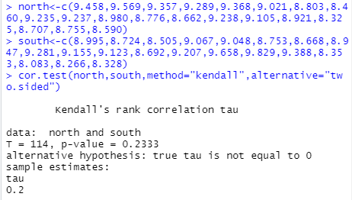

With a p-value of 0.2333, we fail to reject the null hypothesis at alpha=0.10. There is not enough evidence to conclude the Arctic and Antarctic average annual ice area are independent.

- 76 discordant pairs= 190 total pairs – 114 concordant pairs
Two-sided p-value=2*0.1166639=0.2333278
The exact and approximate tests calculated very similar p-values that would fail to reject the null hypothesis at alpha=0.10.

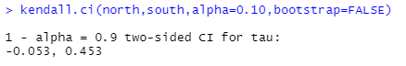

- P(conc)=(1+tau)/2 ((1-0.53)/2, (1+0.453)/2) = (0.4735,0.7265)
We are 90% confident that the true probability of a concordant pair of Arctic and Antarctic average annual ice area is between 47.35% and 72.65%.
- Rank of 2019 for Arctic=3 so 2 data points are concordant.
Rank of 2019 for Antarctic=3 so 2 data points are concordant.
There are 4 total data pairs from 2000 to 2018 that are concordant with the data pair from 2019
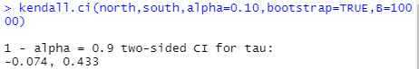

The simulation confidence interval is shifted to the left compared to the approximate confidence interval. The simulation confidence interval is not centered on the tau value of 0.2 while the approximate confidence interval is centered at tau=0.2.

- Sum of squares of differences of ranks = 848
r_{s}=1-(6*848)/(20*399)=0.362406015
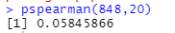

Exact two-sided p-value=0.5845866*2=0.11691732
Large sample approximation r_{s}*= r_{s}/(19)^(1/2)=1.579691196
Normalpdf(1.579691196,0,1)=0.1145606765
Both the approximate and exact tests calculated similar p-values that would fail to reject the null hypothesis at alpha=0.10.
- If Arctic and Antarctic sea ice are uncorrelated, 5 of the 10 years are also expected to have an Antarctic sea ice rank below the median since the probability would be 50%. 7 of the years actually had an Antarctic sea ice rank below the median.

